**Assignment 15 June**

**Name – Atharva Shivaji Jadhav Roll Number - DXC262AB12035**

**Batch – Dxc-262-Analytics-B12-Azure Company – DXC Technology**

**Employee Domain –Azure Analytics Training Under – Manipal Pro Learn**

Assignement - 15th June 2022:

------------------------------

**1.Using archive1.zip file - please ingest data into databricks DBFS path & query the data,**

**redesign columns accordingly using DataFrame commands - display with notebooks accordingly**

Create Cluster and create a notebook attach it to the cluster

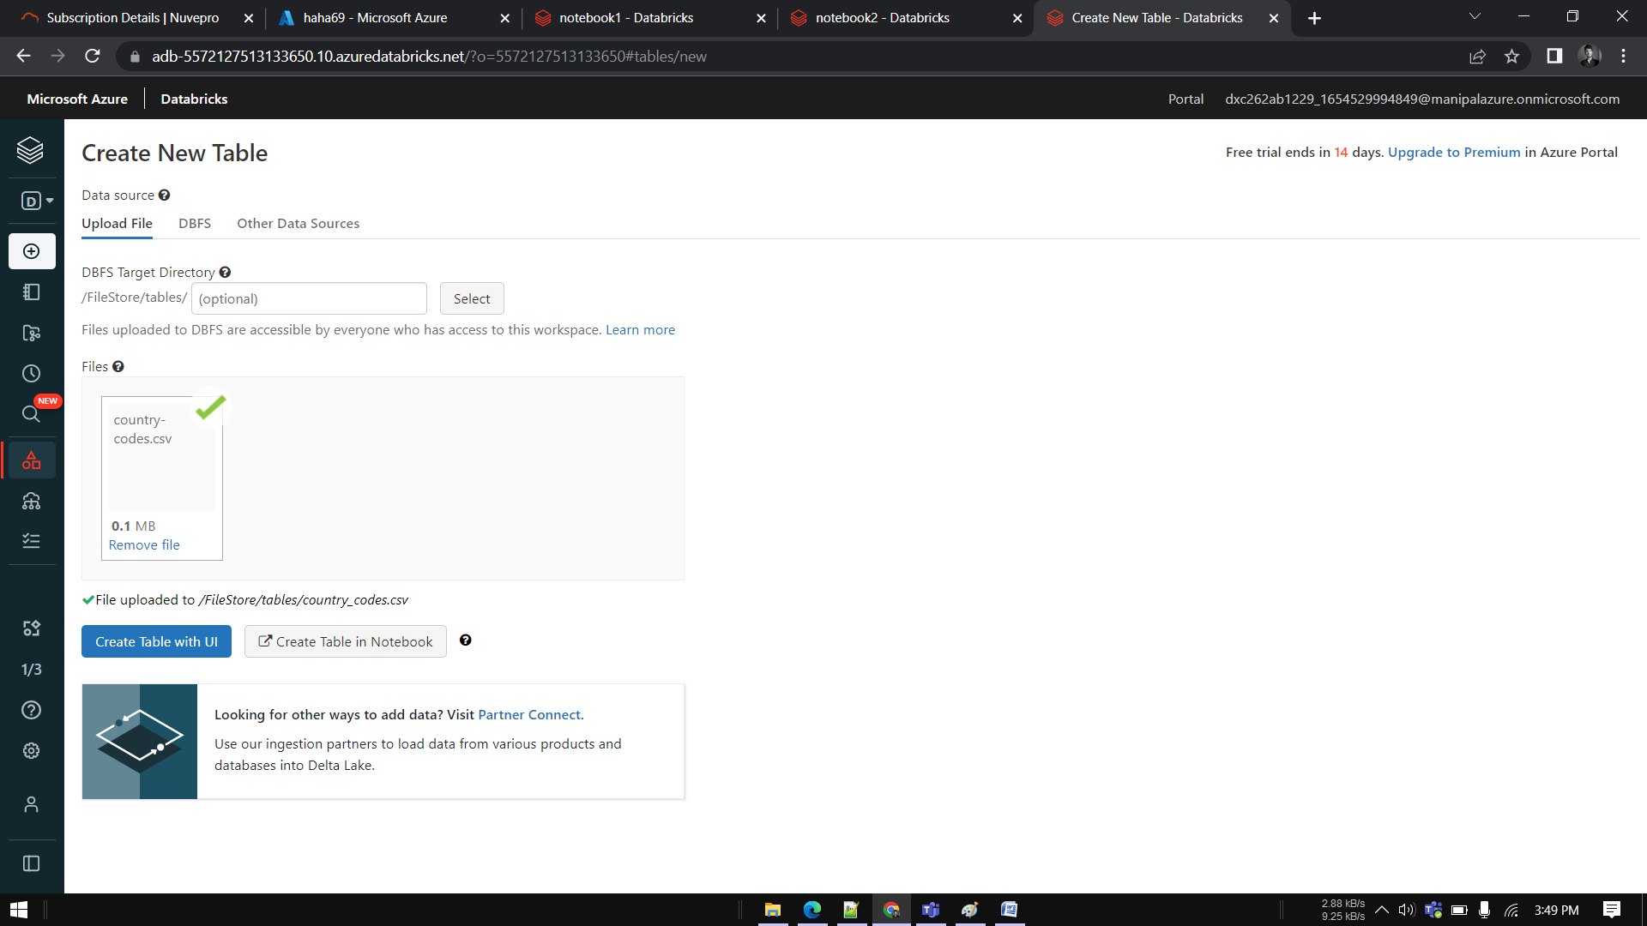

Go to notebook and check whether cluster is running and attached to notebook



Declare data types—

And Run command

from pyspark.sql.types import StructType, StructField, IntegerType, StringType, DateType

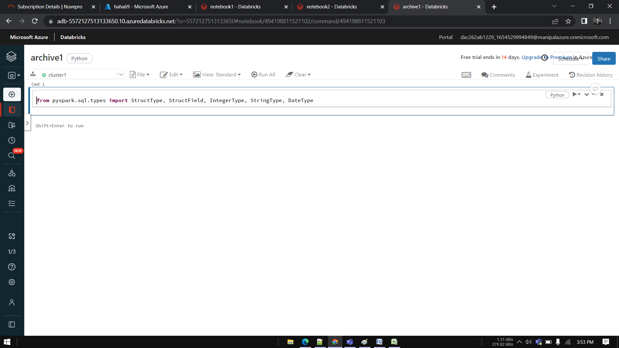

Create schemas –

country_codes_schema=StructType(fields=[StructField("Dial", IntegerType(),False),

StructField("FIFA", StringType(),True),

StructField("MARC", StringType(),True),

StructField("is_independent", StringType(),True),

StructField("ISO3166-1-numeric", IntegerType(),True),

StructField("FIPS", StringType(),True),

StructField("WMO", StringType(),True),

])

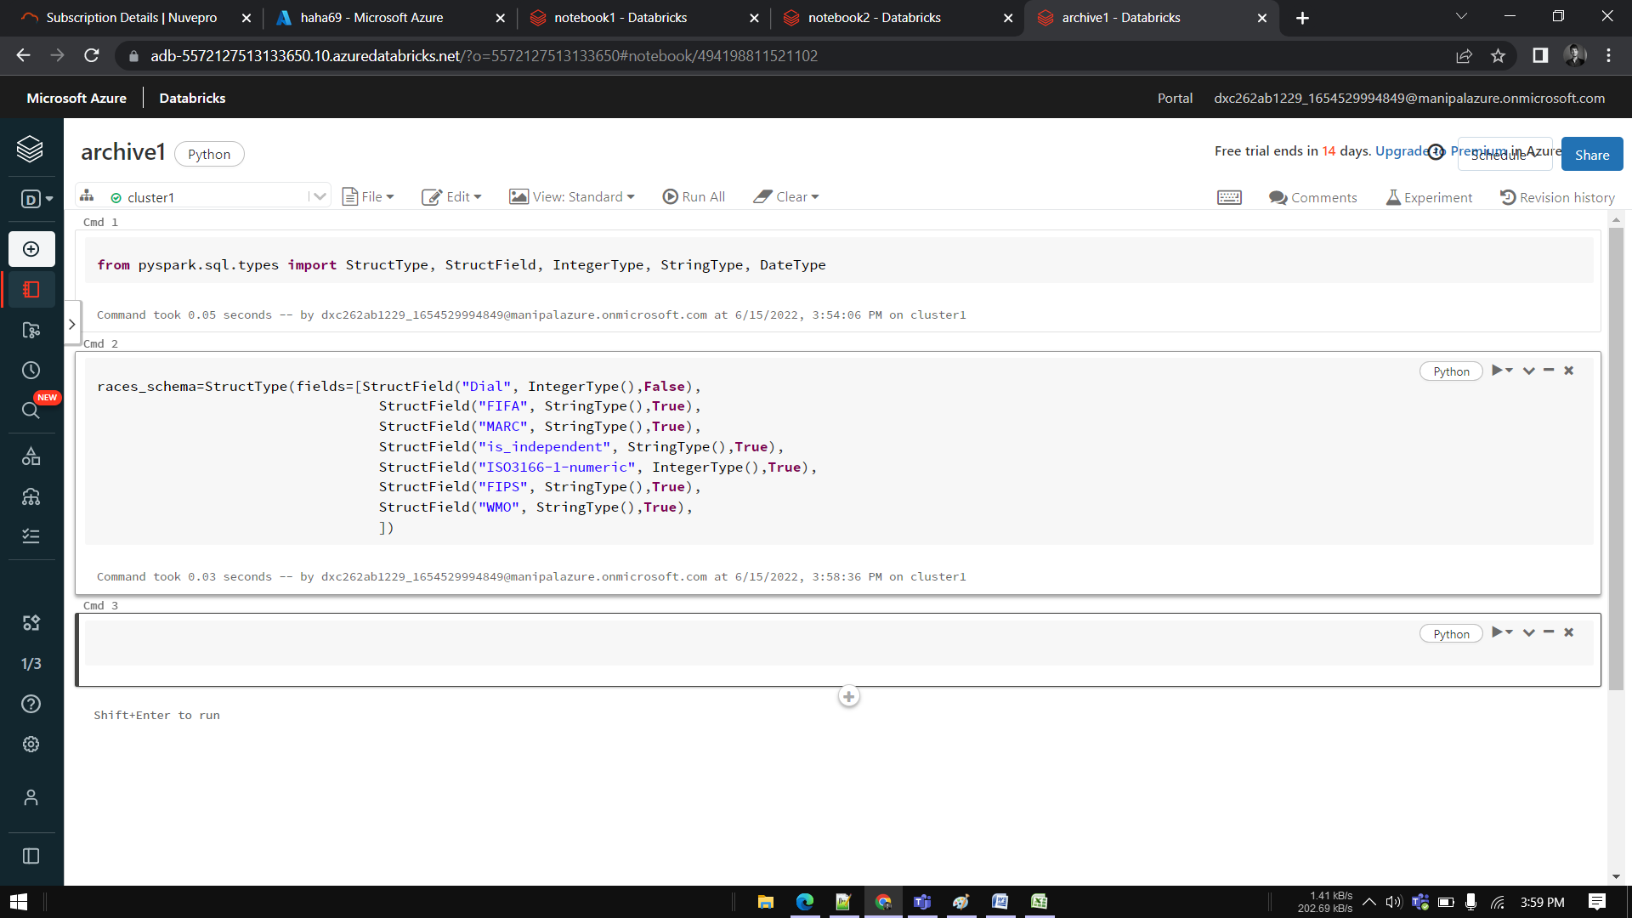

Creating dataFrame

#creating dataframe

country_codes_df = spark.read \

.option("header",True) \

.schema(country_codes_schema) \

.csv("/FileStore/tables/country_codes.csv")

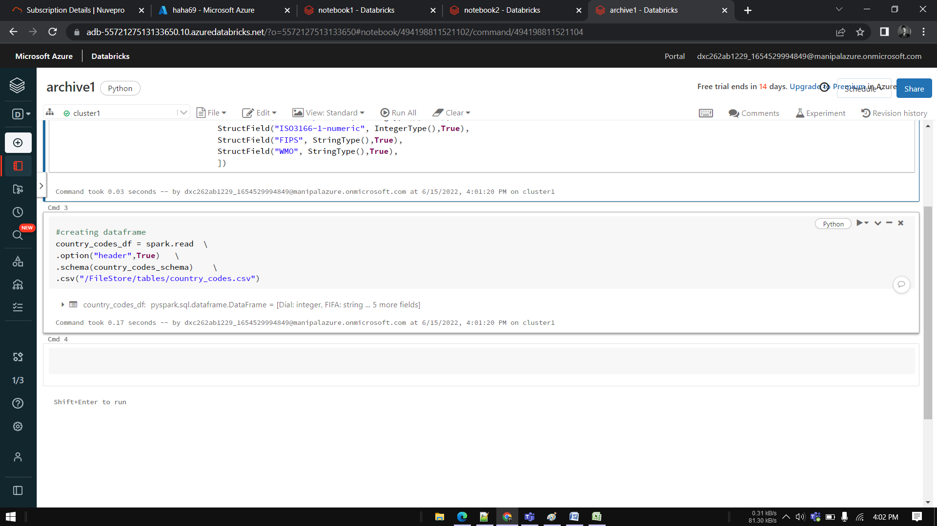

from pyspark.sql.functions import col



country_code_selected_df=country_codes_df.select(col("Dial"), col("FIFA"),col("MARC"),col("is_independent"),col("ISO3166-1-numeric"),col("FIPS"),col("WMO"))

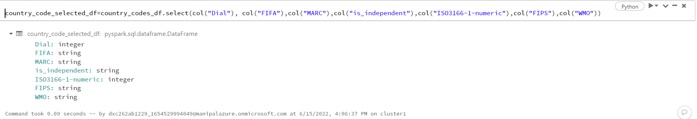

#add injestion date to dataframe

from pyspark.sql.functions import current_timestamp



country_codes_df_final_df=country_codes_df.withColumn("ingestion_date", current_timestamp())

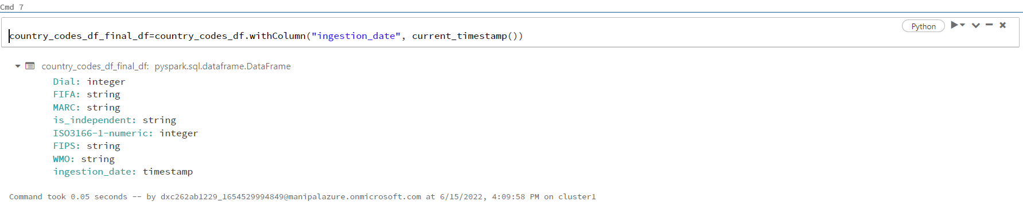

#Write data to datalake as parquet

country_codes_df_final_df.write.mode("overwrite").parquet("/mnt/formula1/processed/country_codes")

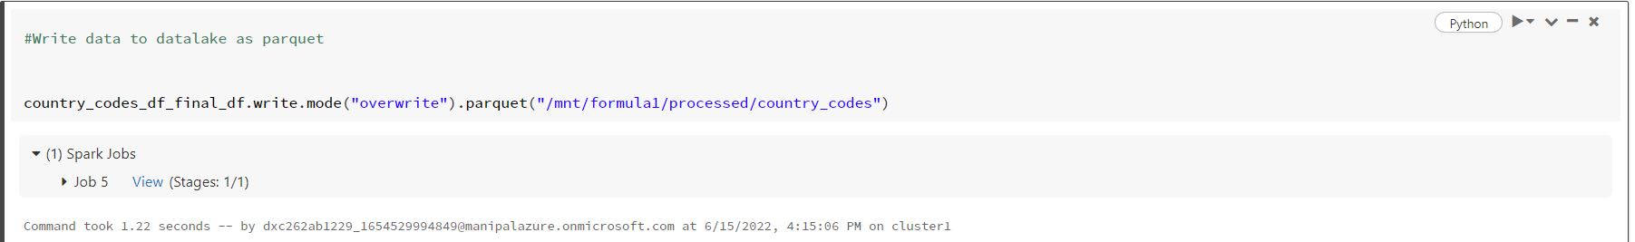

display(spark.read.parquet("/mnt/formula1/processed/country_codes"))

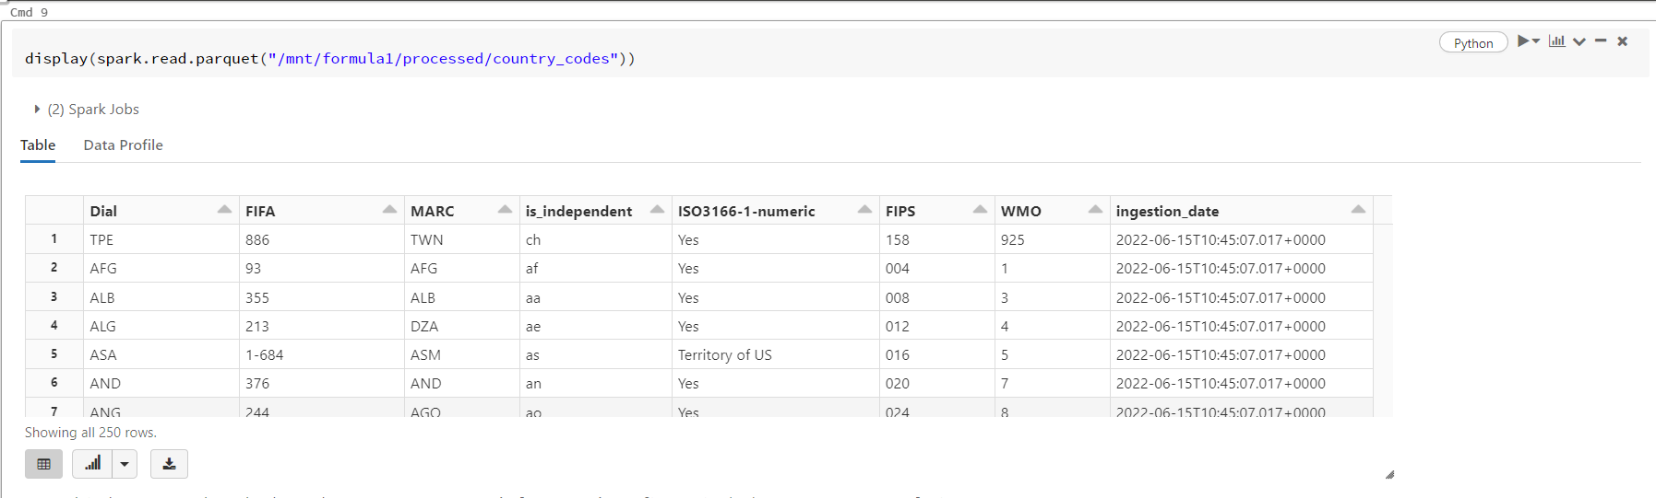

country_codes_with_timestamp_df=country_codes_df_final_df.withColumn("injestion_date", current_timestamp()) \

.withColumn("country_code_timestamp", to_timestamp(concat(col('dial')),'yyyy-mm-dd HH:mm:ss'))

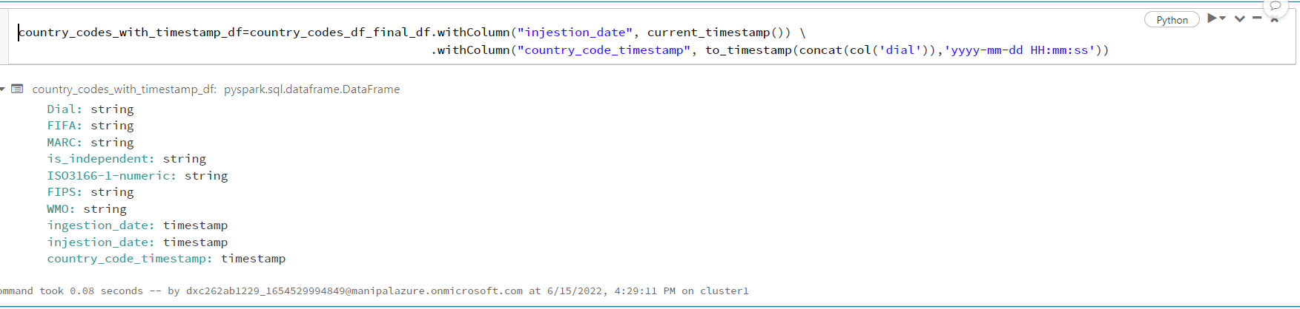

Rename a column—

country_codes_df_final_df.withColumnRenamed("FIFA","ID").printSchema()

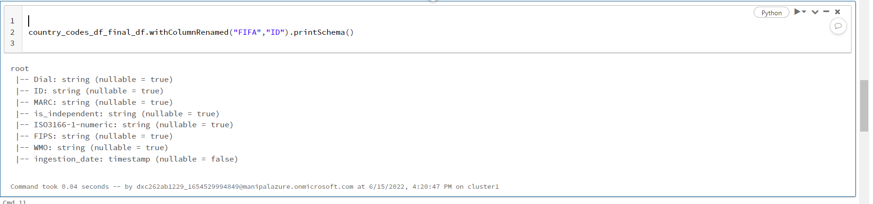

country_codes_with_timestamp_df=country_codes_df_final_df.withColumn("injestion_date", current_timestamp()) \

.withColumn("country_code_timestamp", to_timestamp(concat(col('dial')),'yyyy-mm-dd HH:mm:ss'))

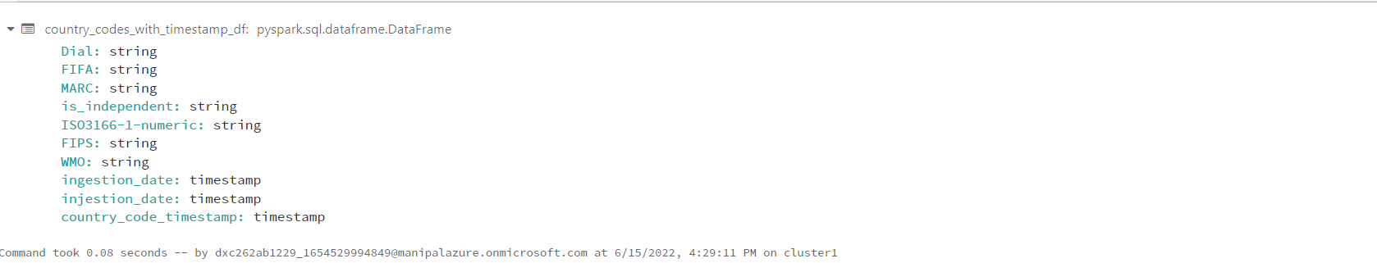

display(country_codes_df_final_df)

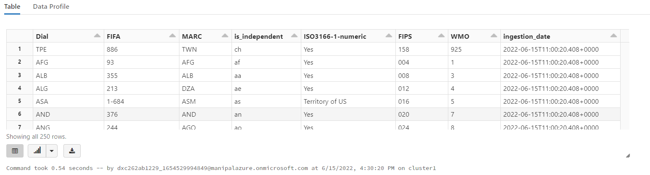

Merge 2 columns—

df=country_codes_df_final_df.withColumn('joined_column', sf.concat(sf.col('FIPS'),sf.col('WMO')))

df.show()

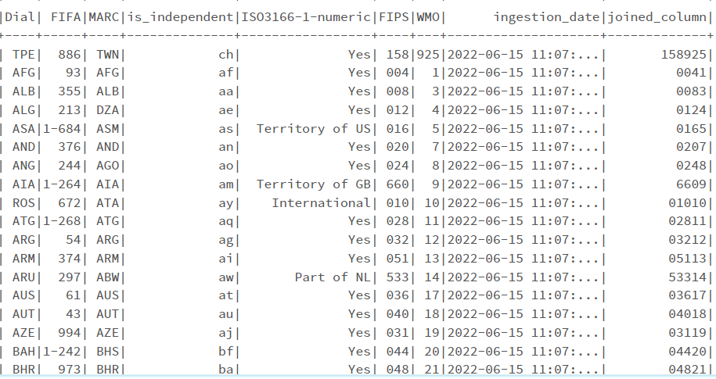

**2.Using archive2.zip file - please ingest data into databricks DBFS path & query the data redesign columns accordingly using DataFrame commands - display with notebooks accordingly**

from pyspark.sql.types import StructType, StructField, IntegerType, StringType, DateType

nces_schema=StructType(fields=[StructField("Value", IntegerType(),False),

StructField("State", StringType(),True),

StructField("Type", StringType(),True),

StructField("Length", StringType(),True),

StructField("Expense", StringType(),True),

])

#creating dataframe

nces_df = spark.read \

.option("header",True) \

.schema(nces_schema) \

.csv("/FileStore/tables/nces330_20.csv")

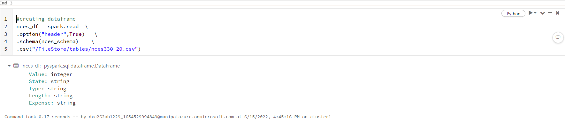

from pyspark.sql.functions import col

nces_dfselected_df=nces_df.select(col("value"),col("State"),col("Type"),col("Length"),col("Expense"))

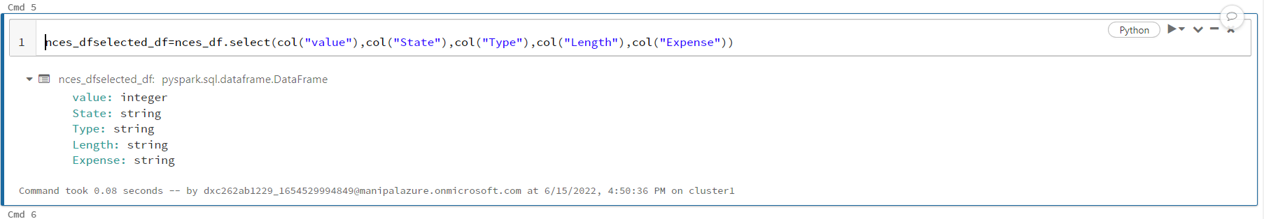

#add injestion date to dataframe

from pyspark.sql.functions import current_timestamp

#Write data to datalake as parquet

nces_df.write.mode("overwrite").parquet("/mnt/formula1/processed/nces")

nces_df.withColumnRenamed("State","state").printSchema()

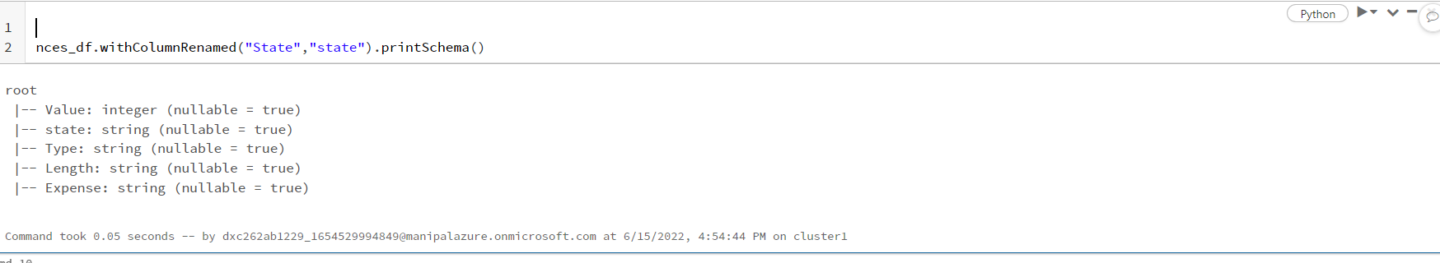

df=nces_df.withColumn('joined_column', sf.concat(sf.col('state'),sf.col('Expense')))

df.show()

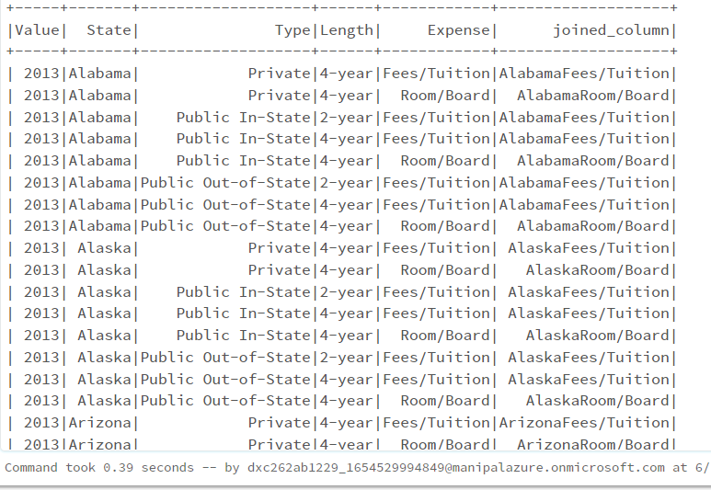

**3.Using archive3.zip file - please ingest data into databricks DBFS path & query the data**

**redesign columns accordingly using DataFrame commands - display with notebooks accordingly**

from pyspark.sql.types import StructType, StructField, IntegerType, StringType, DateType

data_schema=StructType(fields=[

StructField("tweet_text", StringType(),True),

StructField("emotion_in_tweet_is_directed_at", StringType(),True),

StructField("is_there_an_emotion_directed_at_a_brand_or_product", StringType(),True),

StructField("Expense", StringType(),True),

])

#creating dataframe

data_df = spark.read \

.option("header",True) \

.schema(data_schema) \

.csv("/FileStore/tables/final_data.csv")

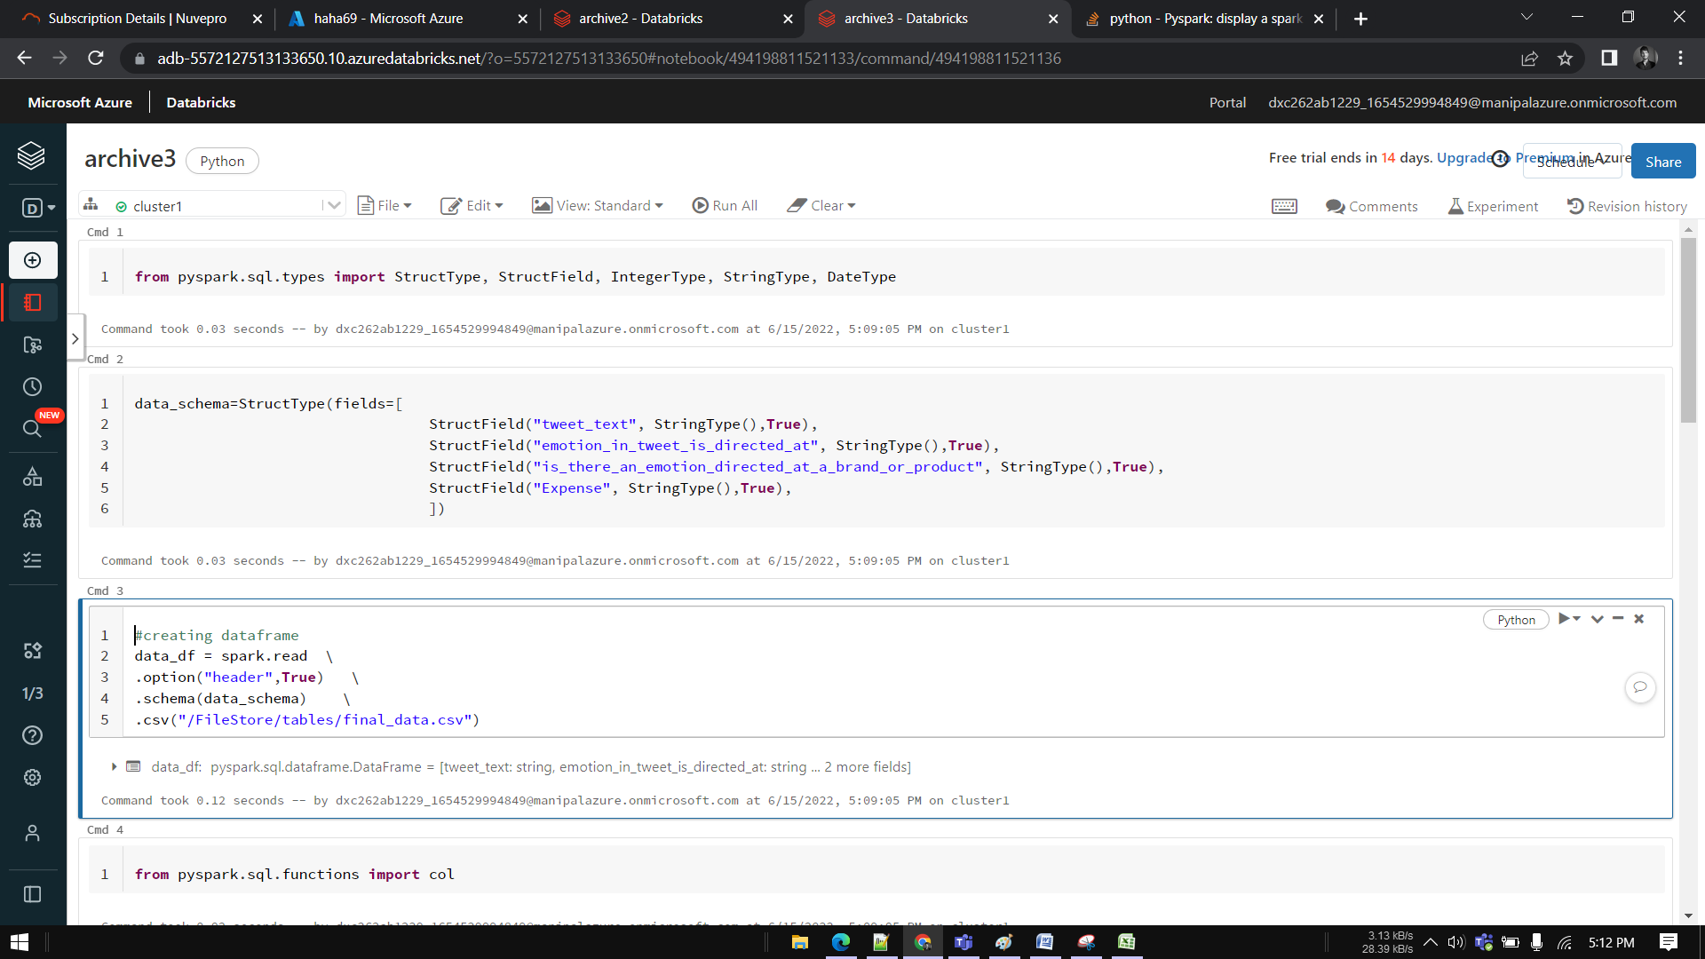

from pyspark.sql.functions import col

data_selected_df=data_df.select(col("tweet_text"),col("emotion_in_tweet_is_directed_at"),col("is_there_an_emotion_directed_at_a_brand_or_product"))

#Write data to datalake as parquet

data_df.write.mode("overwrite").parquet("/mnt/formula1/processed/final_data")

data_df.withColumnRenamed("emotion_in_tweet_is_directed_at","directed_tweet").printSchema()

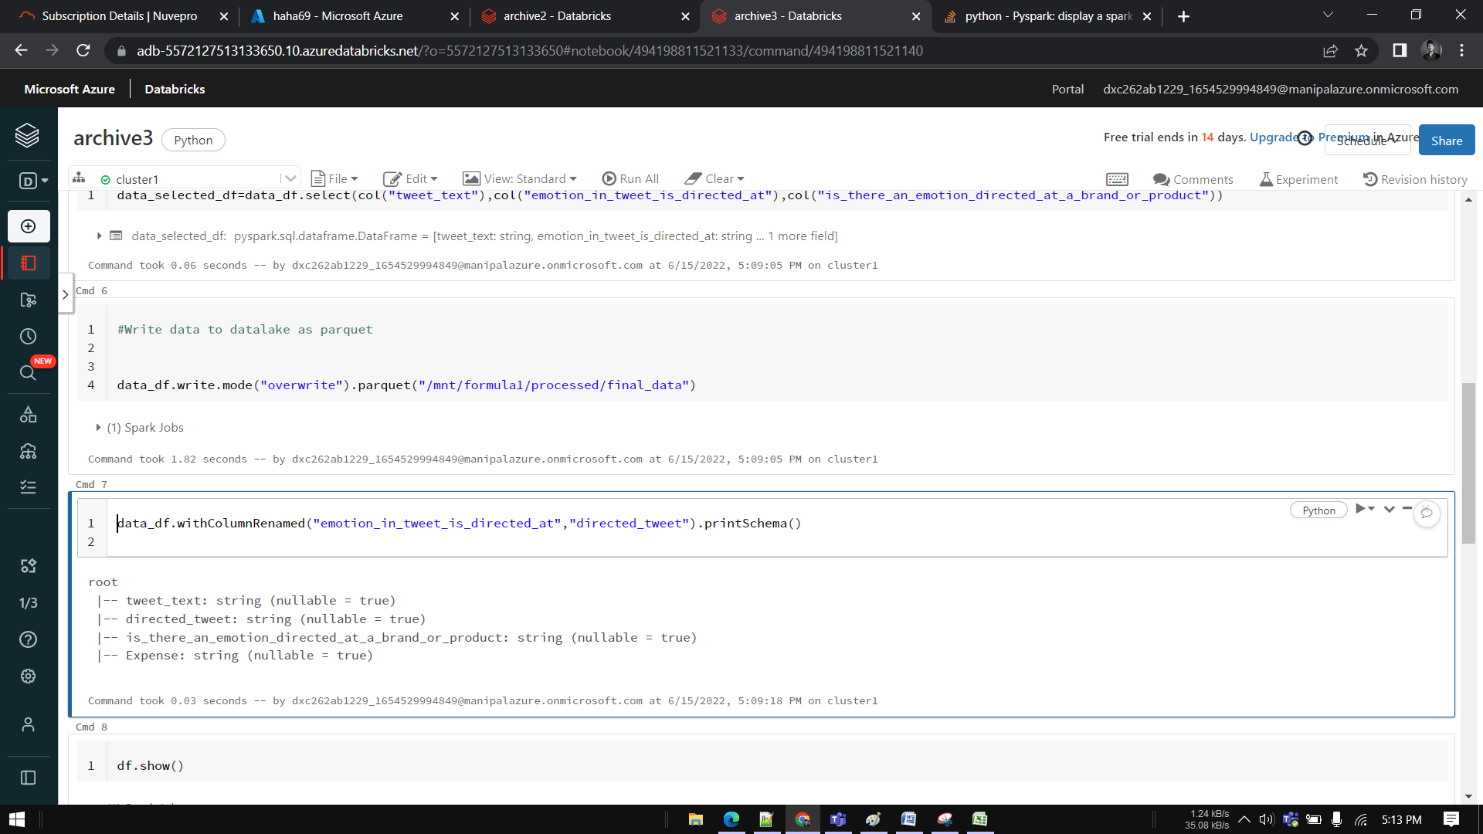

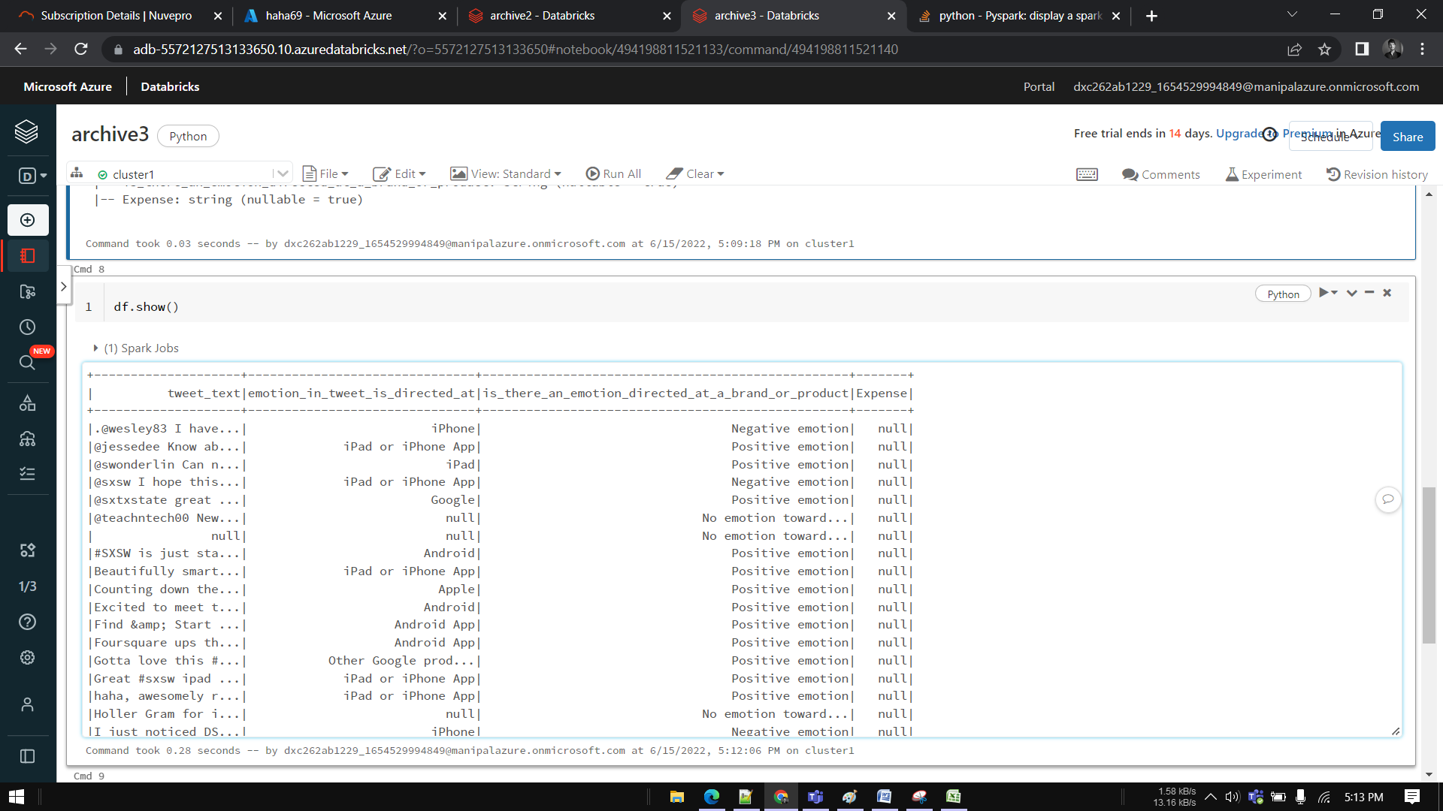

**4.Using archive4.zip file - please ingest data into databricks DBFS path & query the data**

**redesign columns accordingly using DataFrame commands - display with notebooks accordingly**

from pyspark.sql.types import StructType, StructField, IntegerType, StringType, DateType

data_schema=StructType(fields=[

StructField("S No.", IntegerType(),False),

StructField("Title", StringType(),True),

StructField("Decisions", StringType(),True),

StructField("Words", IntegerType(),True),

])

#creating dataframe

senti_df = spark.read \

.option("header",True) \

.schema(senti_schema) \

.csv("/FileStore/tables/SEntFiN-v1.1.csv")

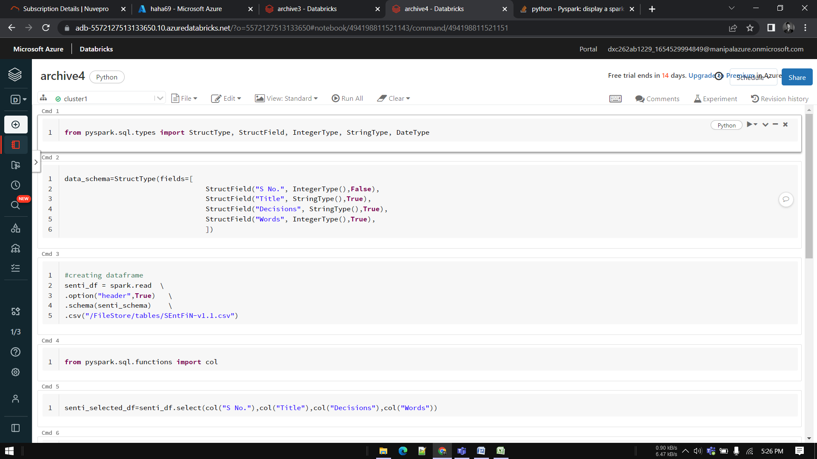

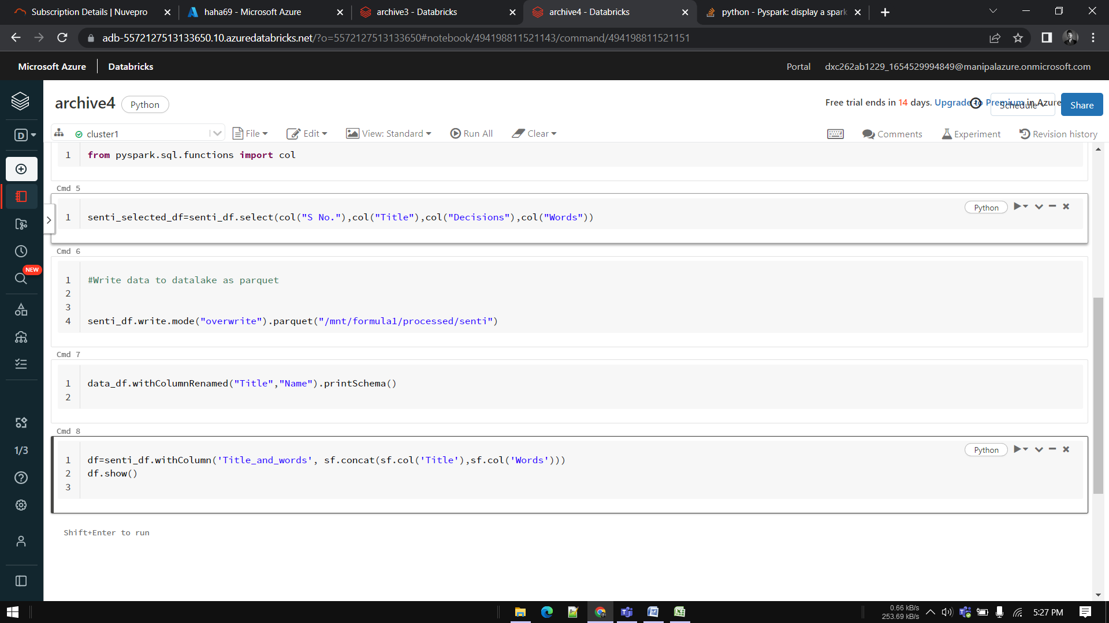

#creating dataframe

senti_df = spark.read \

.option("header",True) \

.schema(senti_schema) \

.csv("/FileStore/tables/nces330_20.csv")

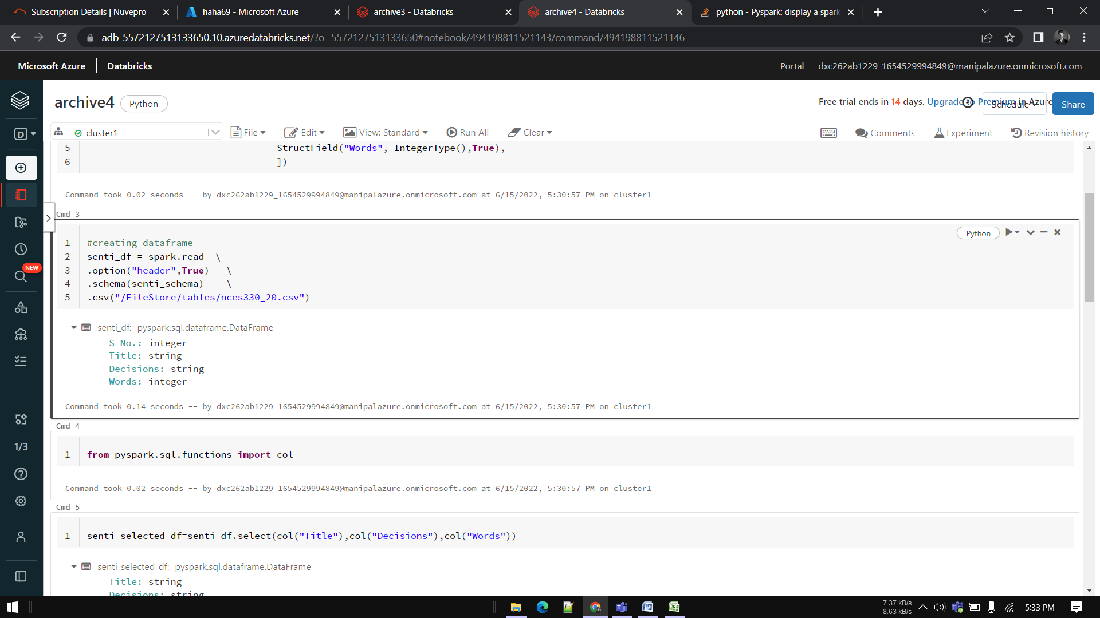

Redesigning a column—

df=senti_df.withColumn('Title_and_words', sf.concat(sf.col('Title'),sf.col('Words')))

df.show()

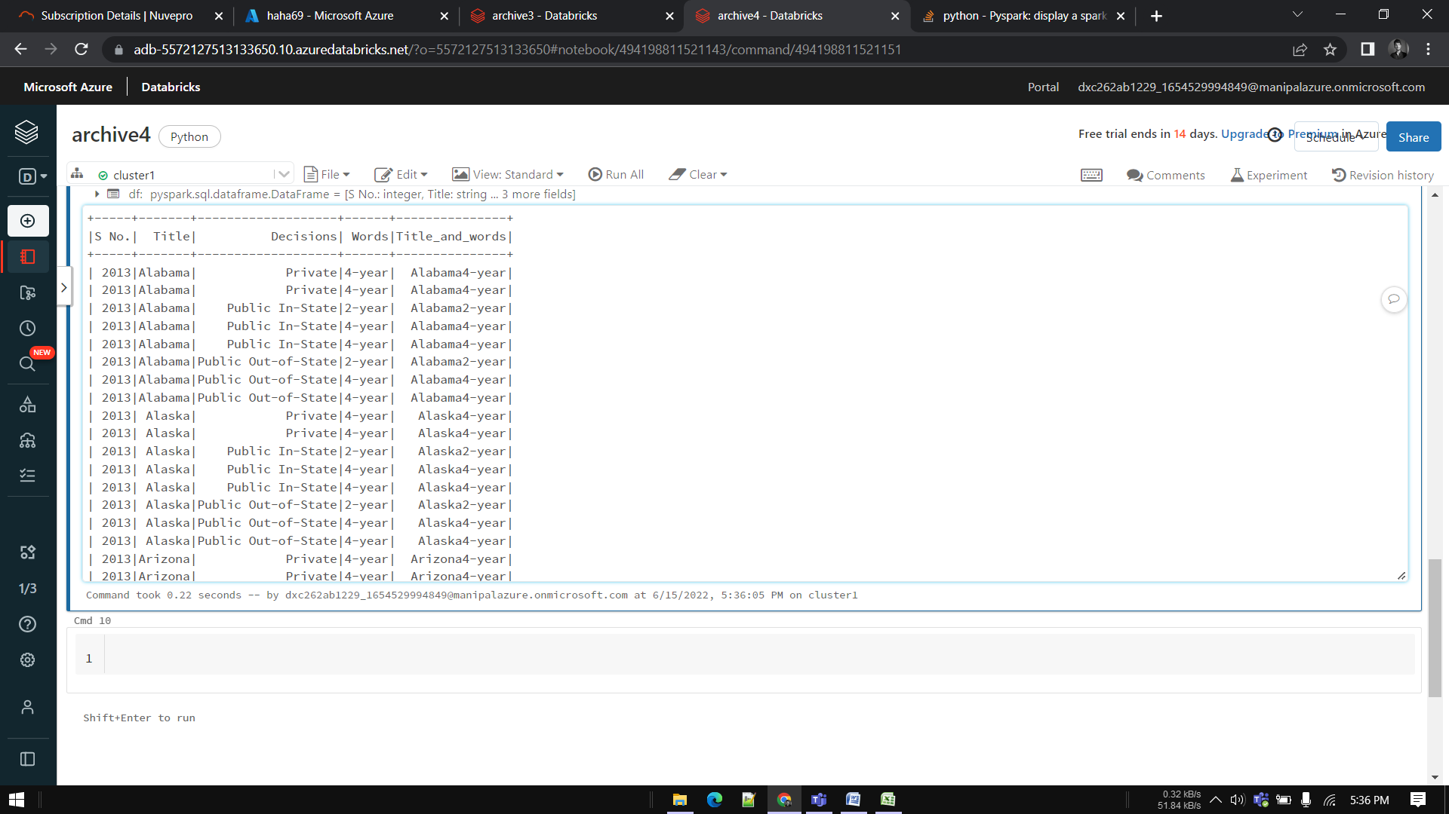

**5.Using archive5.zip file - please ingest data into databricks DBFS path & query the data**

**redesign columns accordingly using DataFrame commands - display with notebooks accordingly**

from pyspark.sql.types import StructType, StructField, IntegerType, StringType, DateType

cancer_schema=StructType(fields=[

StructField("Entity", StringType(),False),

StructField("Code", StringType(),True),

StructField("Year", IntegerType(),True),

StructField("Deaths", IntegerType(),True),

]

#creating dataframe

cancer_df = spark.read \

.option("header",True) \

.schema(cancer_schema) \

.csv("/FileStore/tables/cancer_death.csv")

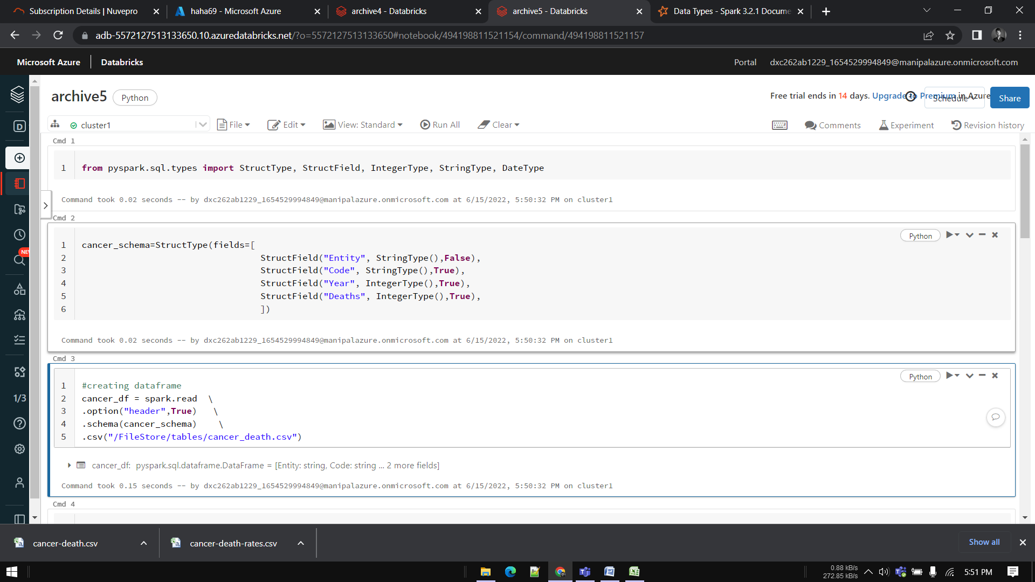

from pyspark.sql.functions import col

#Write data to datalake as parquet

cancer_df.write.mode("overwrite").parquet("/mnt/formula1/processed/cancer")

import pyspark.sql.functions as sf

cancer_df.withColumnRenamed("Code","ID").printSchema()

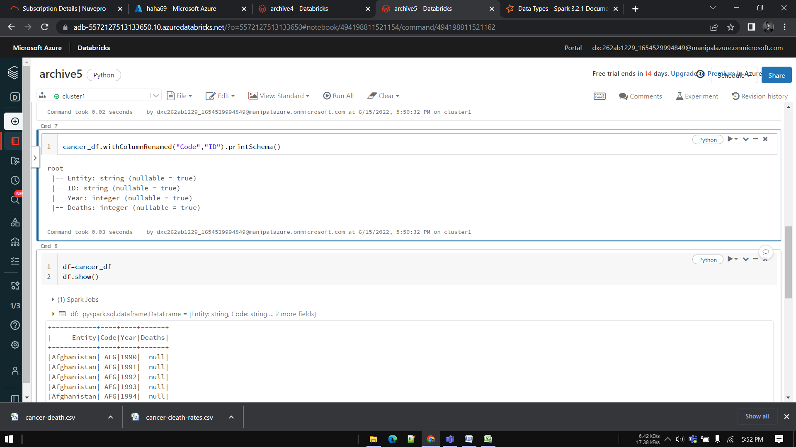

df=cancer_df

df.show()

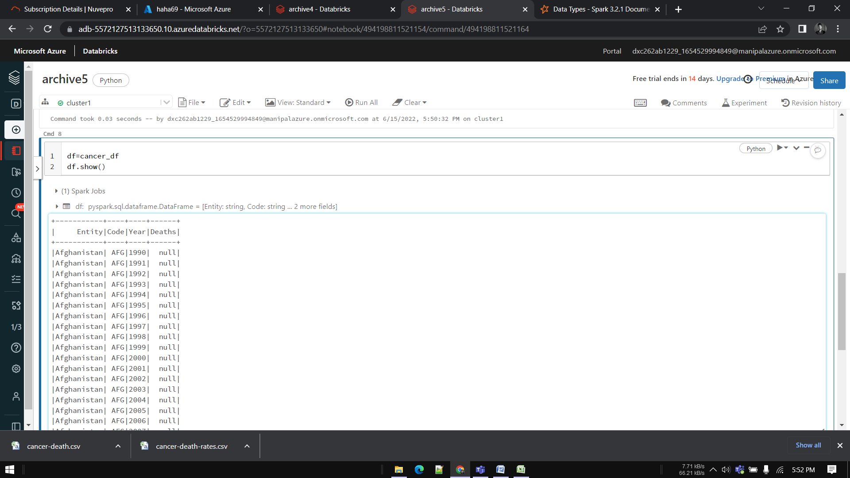

**6.Using archive6.zip file - please ingest data into databricks DBFS path & query the data**

**redesign columns accordingly using data frame commands - display with notebooks accordingly**

from pyspark.sql.types import StructType, StructField, IntegerType, StringType, DoubleType

inflation_schema=StructType(fields=[

StructField("country", StringType(),False),

StructField("county_Code", StringType(),True),

StructField("Year", IntegerType(),True),

StructField("inflation", IntegerType(),True),

]

#creating dataframe

inflation_df = spark.read \

.option("header",True) \

.schema(inflation_schema) \

.csv("/FileStore/tables/inflation.csv")

from pyspark.sql.functions import col

#Write data to datalake as parquet

cancer_df.write.mode("overwrite").parquet("/mnt/formula1/processed/inflation")

import pyspark.sql.functions as sf

cancer_df.withColumnRenamed("code","ID").printSchema()

df=inflation_df

df.show()

Redesigning a column—

df=inflation_df.withColumn('Country_and_code', sf.concat(sf.col(Country),sf.col(Code)))

df.show()

